Planning & Requirements Documentation
for the
Global Support System
Content
1. Project Proposal 3
1.1. Project Name 3
1.2. Project Description 3
1.3. Objectives 3
1.4. Stakeholders 3
1.5. Timeline 4
2. Business Requirements Document (BRD) 4
2.1. Business Problem 4
2.2. Proposed Solution 4
2.3. Key Features 4
2.4. Success Metrics 5
3. Software Requirements Specification (SRS) 5
3.1. Introduction 5
3.1.1. Purpose 5
3.1.2. Scope 5
3.1.3. Definitions 5
3.2. Functional Requirements 6
3.3. Non-Functional Requirements 6
4. Use Cases 7
4.1. Use Case 1: Login 7
4.2. Use Case 2: Bike and Helmet Management 8
4.3. Use Case 3: Location, Key, and Accommodation Management 8
4.4. Use Case 4: Track Bag 8
4.5. Use Case 5: Assets management 8
5. System Requirements Specification 9
5.1. Software 9
5.2. Hardware 9

Project Proposal

Project Name
Global Suport System (GSS)

Project Description
The Global Support System (GSS) is a secure, web-based platform designed to manage logistics and resources in a multi-camp or organizational setting. It facilitates operations across modules like asset inventory, accommodation, laundry tracking, bicycle rentals, and access control. GSS also integrates two-factor authentication (2FA), NFC/RFID hardware support, session management, and real-time reporting.

Objectives
- Centralize support operations (e.g., assets, accommodation)
- Enable secure login and user role management
- Provide real-time analytics and data export
- Support NFC/RFID-based identification and operations
- Allow scalable, camp-based modular administration

Stakeholders
- System Administrators (admin role)
- Laundry Supervisors
- Accommodation Managers
- Asset Managers
- Field Operators with RFID/NFC devices
- IT Support Team

Timeline
- Requirements Gathering: 1 weeks
- Design & Architecture: 2 weeks
- Backend Development: 6-8 weeks
- Android App Dev: 6-8 week
- Integration Testing: 2 weeks
- Deployment: 1 weeks
- Total Duration: ~19 weeks

Business Requirements Document (BRD)

Business Problem
Managing logistics like accommodations, assets, and laundry across multiple camps manually or through disconnected systems leads to inefficiencies, delays, and data inconsistencies.

Proposed Solution
Develop a secure, modular web-based system with user roles, data validation, tracking, and reporting features that can be used from both desktop and mobile devices.

Key Features
- Secure user login with 2FA
- Real-time asset tracking and editing
- Accommodation and key assignment
- NFC-based bike and helmet rentals
- Laundry bag lifecycle tracking
- Clean UI built with EJS and Bootstrap
- Exportable Excel reports using excelJS

Success Metrics
- Reduction in manual asset errors by 90%
- 100% user adoption across all camps within 2 months
- Ability to process and log 100+ transactions/minute
- Zero critical security breaches post-launch

Software Requirements Specification (SRS)

Introduction

Purpose
Define software requirements for the Global Support System, which supports camp operations through web and mobile interfaces.

Scope
The software handles user authentication, resource assignment, rentals, tracking, and reporting across laundry, accommodation, assets, and transport operations.

Definitions
- Camp: A physical location with managed assets, rooms, and users
- 2FA: Two-Factor Authentication
- RFID/NFC: Radio Frequency and Near-Field Communication technologies
- Helmet/Bike Codes: Equipment identifiers used in rentals
- Bags: Laundry bags tracked across service points

Functional Requirements
- FR1: User authentication with username, password, and 2FA via TOTP
- FR2: Add, update, and delete camps and associated data
- FR3: RFID/NFC integration for scanning and validating assets and users
- FR4: Manage assets with status tracking, repair marking, etc.
- FR5: Track accommodation occupancy with room/key allocation
- FR6: Track laundry bags through different lifecycle statuses
- FR7: Export detailed Excel reports for management review

Non-Functional Requirements
- NFR1: CSRF and session protection using csurf and express-session
- NFR2: Brute-force protection for login
- NFR3: Secure headers using Helmet and custom CSP
- NFR4: Mobile-compatible Android APKs with hash validation
- NFR5: Scalability with PostgreSQL and modular route separation
- NFR6: Support for up to 500 concurrent users

Use Cases
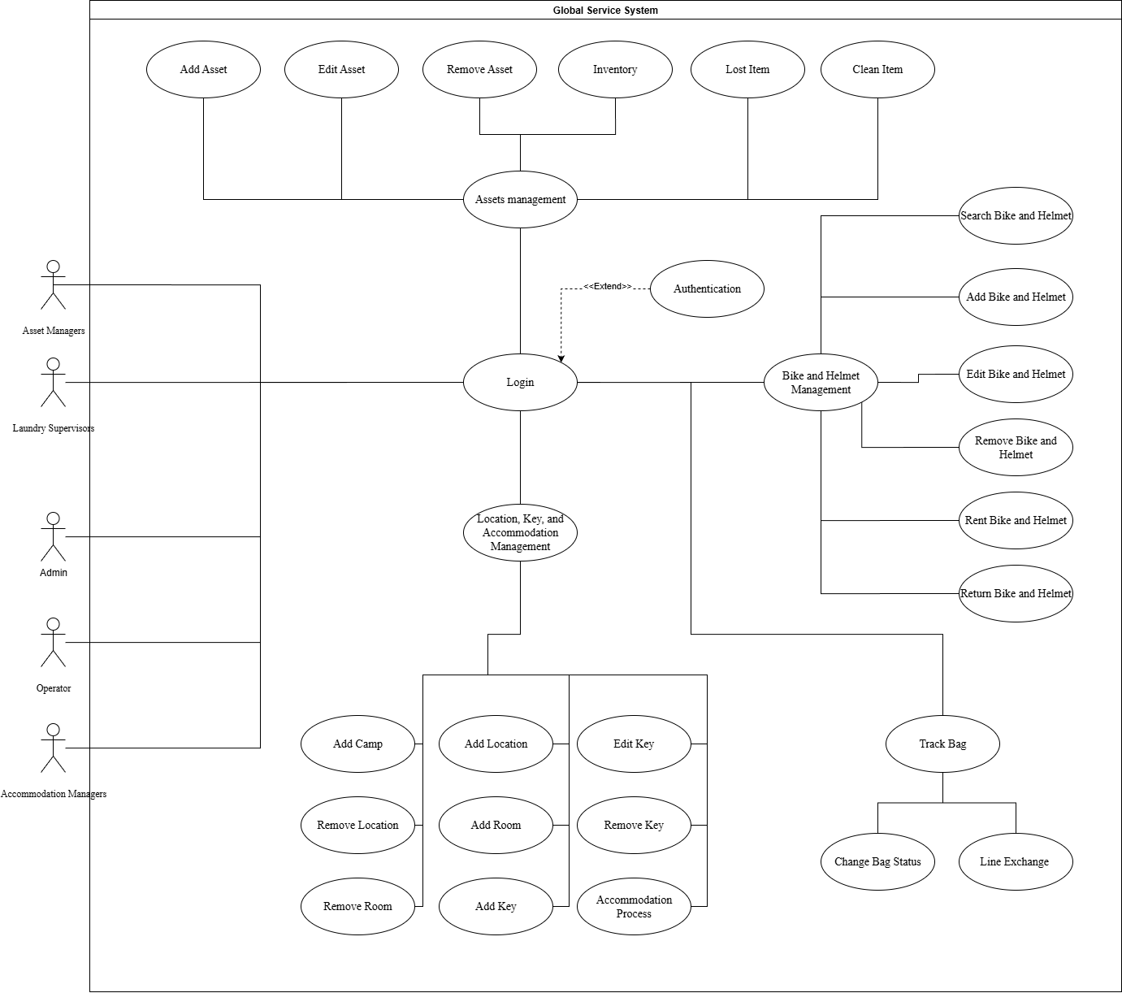
Diagram 1: Use case diagram

Use Case 1: Login
- Actor: Admin/User
- Goal: Logs in through a form and verifies using a Two-Factor Authentication (2FA) token.
- Success: The user is authenticated and redirected to the home page.

Use Case 2: Bike and Helmet Management
- Actor: Operator
- Goal: Manage and maintain the data and operational status of each bike and helmet.
- Success: Improved data quality and traceability, ensuring accurate status tracking and efficient inventory management.

Use Case 3: Location, Key, and Accommodation Management
- Actor: Accommodation Managers
- Goal: Manage hierarchical location data, monitor key usage and availability, and support accommodation logistics.
- Success: Structured and traceable hierarchy of locations and keys; real-time key occupancy tracking and efficient space allocation.

Use Case 4: Track Bag
- Actor: Laundry Supervisors
- Goal: Update and track the status of laundry bags at different process points (e.g., drop off, transportation to laundry facility, laundry facility, …).
- Success: Real-time visibility and traceability of each bag's status, reducing loss and improving operational efficiency.

Use Case 5: Assets management
- Actor: Asset Managers
- Goal: Register, monitor, and update details of physical assets such as equipment, furniture, and tools.
- Success: Centralized and updated asset database with complete tracking of asset location, condition, and responsible personnel.

System Requirements Specification

Software
- Backend: Node.js with Express.js
- Frontend: EJS templating, Bootstrap 5
- Database: PostgreSQL
- Security: Helmet, CSRF protection, bcryptjs for password hashing
- 2FA: speakeasy, qrcode
- File Handling: Multer memory storage
- Excel Reports: exceljs, xlsx

Hardware
- Server: 2-core CPU, 4GB RAM, 50GB SSD (minimum)
- Client: Any browser-compatible device or Android device with NFC reader
- Android Scanners: Chainway C5 or compatible models with RFID/NFC

